FINANCIAL ACCOUNTING

CSR LIMITED

BACKGROUND

CSR Limited (colonial sugar refining company founded in Sydney in 1855, Employees having more than 4200, 220+ manufacturing distribution sites, 12000+ customers across Australia and New Zealand, CSR is one of the Australia oldest manufacturing company. CSR expended into milling cane in Queensland and Fiji from the 1870s and it the one of the oldest Australian manufacture companies having 25% share in the Tomago aluminium smelter located near Newcastle, NSW and it is publicly traded on the Australian Securities Exchange. According to the report of 2014 it has the 2985 numbers of employee, revenue was $1.74 billion, operating income were $125 million and the net income was $88 million. And today it is one of the leading building product company in New Zealand and Australia. One of the market most trusted and recolonized brands. Its ASX code is ASX:CSR. Its main office is located at North Ride, NSW, Australia. Its main website is (http://www.csr.com .au). The main purpose of this company is to build materials, and providing different types of household stuff like, glass, plaster board, bricks, insulation, aluminium and providing construction services as well and it also sold the by product the sugar industries, from molasses to ethanol. (Anon., 2018)

CSR REVENUE

Year 2018 the company total revenue is $2.6 billion. As CSR products are a core part of the industry and manufacturing different products for homes and building where people live, work, and play like, Viridian glass, Aluminium, and other property. CSR has been continued its record of growth in earning for 5 consecutive years, 4 different factor company earning include, Building products (EBIT) 214.1 million, Viridian glass (EBIT) 3.5 million, Aluminium (EBIT) 79.5 million, Property (EBIT) 47.8 million by current year.

According to report the financial statement of the company the total gross profit of 2018 is $863.8 million where as in 2017 was $833.7 million.

From 1 April 2016 there was a change in internal reporting which resulted in transfer of operating expenditure from cooperate to building products as a result, the comparative years have been updated to reflect this change. CSR profit after tax (before significant items) was 16% in the year to $212.7 million and statutory profit of $188.8 million was up 6%.

The growth in earning over the last 5 years has delivered higher dividends, maintaining CSR policy of paying dividends between 60-80% of full year net profit after tax. CSR have resolved to pay a final dividend of 13.5 cents per share, franked at 75% which will bring the full year dividend to 27 cents, up 4%.  
CSR also continues to maintain a strong balance sheet with net debts of $14.3 million, slightly up on last year. CSR are also advanced in the construction of their new $75 million Hebel factory in Somersby, NSW.

Some of the strategy taken by CSR to improved revenue even more are in:

1. Aluminium

Sales volumes of 212,801 tonnes were up 1% due to operational improvements at the Tomago smelter. Trading revenue of $565.5 million was up 11% reflecting 10% improvement the realised aluminium price.

1. Trading revenue from building products was $1.7 billion, up 6%, with higher volumes and improved pricing across most products and segments.
2. EBIT was up 6% to 214.1 million with earnings, reflecting the benefits of improved factory performance, price increase and cost management. The result includes investment of approximately $10 million in a number of growth initiatives.
3. EBIT margin of 12.8% was down slightly from 12.9% as improved volume, pricing and product mix offset $9 million in higher energy costs.
4. The balance of the viridian businesses improved performance with increased with increased pricing and product mix, offset by $4 million in the higher energy costs. In Australia, demand for higher performing glass in the residential market is also increasing following new BASIX energy targets in NSW which became effective in July 2017 while in Victoria, IGU sales accounted for over 60% of revenue in YEM18.

CSR recent improvement YEM18

* Improvement in safety LTIFR.
* 29% of CSR directors are women
* 45% improvement in days lost as a result of work-related injuries
* 20% in senior management positions – in line YEM17
* 8 stars ongoing building science research at CSR house
* $3 million funding from the Federal government to support CSR in closet TM building façade system.
* CSR connect launched three years ago, providing 24/7 access to accounts, pricing, payment, and delivery tracking
* $20 million energy improvement fund established
* Reduction in waste sent to landfill in 2017
* Exceeded 2020 target to minimise waste production and c02-e emissions per tonne of saleable product
* $108,670 donated to CSR community support program in YEM18

History of CSR share price of last 5 years

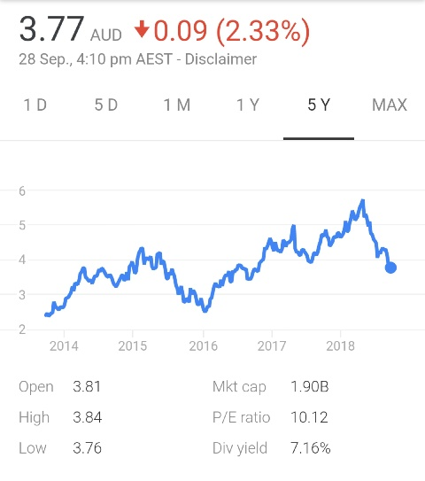

As we can see according to the chart, October 4, 2013. Share price was 2.40, which increased until April 24, ($3.76) 2014. And the overall we can see the highest share price of CSR has been in May 4, 2018 ($5.74). However, it has been project that shares price will be decreasing so far. The growth rate of earning last 5 years has delivered higher dividends for shareholders while company financial position remains strong.

Property, Plants and equipment

Property, plants and equipment refers the fixed asset of the company which is not usually converted into cash within the 12-month period. Property, plants and equipment are long term physical assets like, land and buildings, furniture, machinery, vehicles etc. As this is the building company so it’s usually focuses on land and buildings.

As compared to financial statement 2017-18 of building company the property, plants and equipment seems to decrease from $848.2 to $834 million. The reasons for the decrease in assets may be Disposal, written down and impairment, exchange differences or acquisition through business combinations. During the period the assets is being impaired but while in case of acquisition some assets were revalued. As we go through the segment information, we can be building product, glass, aluminium, property. As given in statement some impairment has taken place due to different condition detail as per statement is as follows:

During the year ended 31 March 2018, the Glass segment divested sites in Western Australia, Darwin and Cairns. Significant items recorded include the loss on disposal and associated restructuring expenditure of $8.7 million and a provision for onerous lease costs of $8.7 million. In addition, the Aluminium segment recorded a charge of $1.0 million for restructuring costs. During the financial year ended 31 March 2017, restructuring and relocation programs took place across the Building Products, Glass and Aluminium segments to align the business cost base with current market conditions and secure ongoing efficiencies. In addition, in the year ended 31 March 2017, following a routine review of plant and equipment, asset impairments were recorded in the Building Products segment to reduce the carrying value of assets to their recoverable amount.

Provision

|  |  |  |  |  |  |
| --- | --- | --- | --- | --- | --- |
| **$ million** | 2017 | Recolonized/ remeasured | Settled transferred | Discount unwind | 2018 |
| Employee benefit | 113.5 | 58.2 | (60.9) | - | 110.8 |
| Restructure and rationalisation | 9.3 | 6.2 | (4.4) | - | 11.1 |
| Product liability | 29.2 | 32.5 | (31.7) | - | 30.0 |
| Restoration and environmental rehabilitation | 8.2 | 3.5 | (9.7) | - | 2.5 |
| Uninsured losses and future claims | 5.6 | 10.9 | (10.7) | - | 5.8 |
| Other | 19.8 | 15.9 | (18.9) | - | 16.8 |
| **Total current provisions** | **186.1** | **127.2** | **(136.3)** | **-** | **177.0** |
|  |  |  |  |  |  |
| Employee benefit | 5.2 | 0.1 | 2.6 | - | 7.9 |
| Product liability | 283.2 | (32.5) | - | 8.3 | 259.0 |
| Restoration and environmental rehabilitation | 1.0 | 0.2 | 2.2 | - | 3.4 |
| Uninsured losses and future claims | 22.2 | - | 0.5 | 0.6 | 23.3 |
| Other | 8.2 | 0.4 | 6.1 | 0.1 | 14.8 |
| **Total non- current provision** | **319.8** | **(31.8)** | **11.4** | **9.0** | **308.4** |

As we know that the provision is recognised when the CSR group has a present obligation because of the past event, it is probable that settlement will be required and the obligation can be reliably estimated. And the CSR have the provision for uninsured losses and future claim which is related to the CSR groups self-insurance of their workers compensation program.

A potential asset associated with a contingent gain is known as contingent assets. Examples of a contingent assets and gain might be lawsuit field by CSR against another company ‘Y’ for infringement of company CSR patient. If it is probable that the CSR will win the lawsuit and will receive some estimated amount of money and we recorded as them contingent gain that amount of money.

The liability which may rise depending on the outcomes of some specific events are known as the contingent liability. These are the possible obligation which can be raised by the future event. When it can be estimated then it will have recorded or should be disclosed. Example: product warranties & potential lawsuit or some pending investigations, etc. Examples: if I took education loan of $300000 from my own bank to fund my child’s higher education and this amount will be contingent liability if my child failed to pay the amount after getting a job. And I must pay the remaining amount to my bank.

We know that the provision is a liability with uncertain amount or timing but it satisfies the definition of a liability and most importantly it satisfies the recognition criteria whereas contingent liability cannot fulfil the definition of liability or could a present obligation.

BASIS OF PROVISION

CSR includes in its financial statements a products liability provision covering all known claims and reasonably foreseeable future asbestos related claims. This provision is reviewed every six months. CSR does not believe there is any significant source of insurance available to meet its asbestos liability. CSR no longer has general insurance coverage in relation to its ongoing asbestos liability.

At 31 march 2018, a provision of $289 million (31 march 2017: $312.4 million) has been made for all known claims and reasonably foreseeable future claims, and includes a prudential margin of $55.7 million (31 march 2017: $60 million) above the aggregate most likely estimate of the future asbestos liabilities in Australia and the Nathan Associates, Inc. respectively.

Table shows Five years’ history – asbestos provision

|  |  |  |  |  |  |
| --- | --- | --- | --- | --- | --- |
| millions | 2104 | 2105 | 2106 | 2017 | 2018 |
| United states base case estimate US $ | 123.5 | 104.9 | 86 | 72.2 | 51 |
| United states base case estimate A$ Australian central estimate A$ | 133.5  161.8 | 137  157.2 | 112.2  157.1 | 94.5  157.9 | 66.6  166.7 |
| Subtotal A$  Prudential margin A$  Prudential margin % | 295.3  73.8  25.0% | 294.2  56.5  19.2% | 269.3  65.2  24.2% | 252.4  60  23.8% | 233.3  55.7  23.9% |
| Total product liability provision A$ | 369.1 | 350.7 | 334.5 | 312.4 | 289 |
|  |  |  |  |  |  |
|  |  |  |  |  |  |

Responsibility and Sustainability

As we know that not only the business is our responsibility to look the environment and the society must be our view as well. Australia is driest country on earth because of which CSR recognised the importance of using water efficiency. If we see the history of CSR, their stormwater and disposal of water used at their manufacturing facilities are central to on site environmental plans.

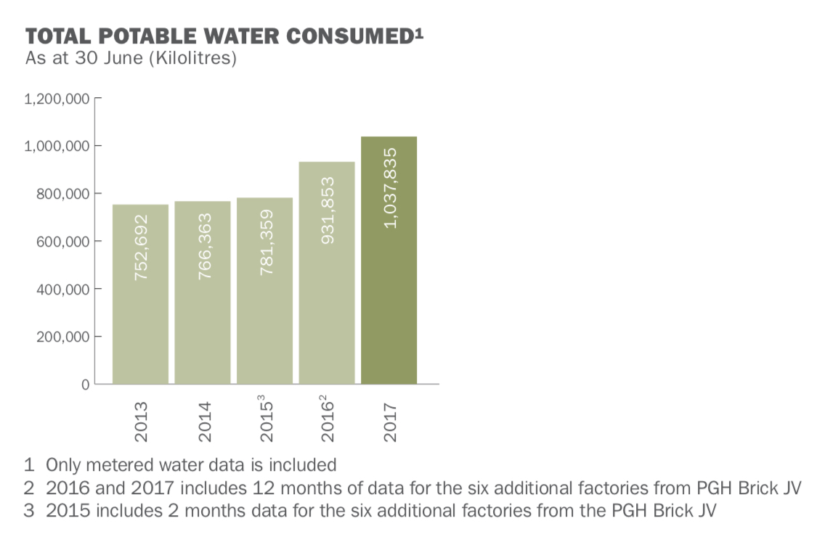

Fig: Potable water consumed

If we compared CSR report of water consumed, it was 1037838 kilolitres of potable water during the year ended 30th June 2017 and 30th June 2016 it was 931853 kilolitres which is around 11% higher because of higher production. Now CSR are trying to implement water saving measures across manufacturing site to reduce excess amount water.

If we look back to the waste, to reduce the waste is also the key priority to the company. Now CSR are using recycled material as much as they can like, using recycled glass cullet in the production of Braford glass wools insultation and recycled paper are used Gyprock plaster board.

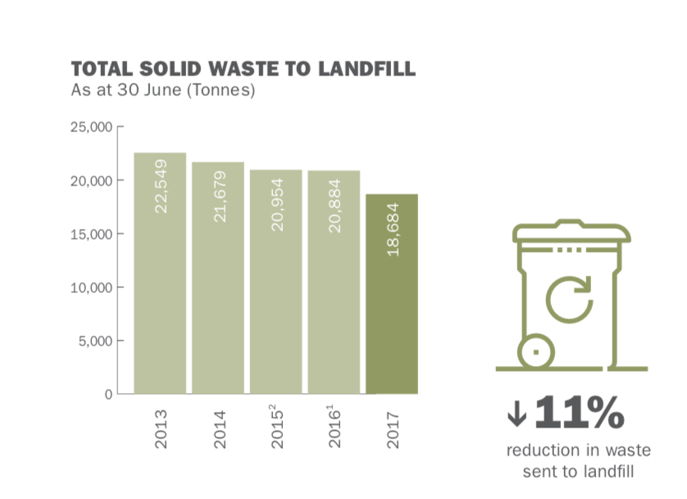

Fig: Solid waste

From above picture we can clearly see that the no of solid waste is decreasing year by year. If we look on year 2017, 18684 tonnes of solid waste produced by CSR where as in year in year 2016, there was 20844. In year 2015, it was recorded 20954 tonnes. If we compared between year ended 2016 & 2017, 11% down on the previous year despite higher level of production activity.

CSR also aiming for the zero environmental incident. CSR made environmental incident report based on 5 level of breaches which are reported to regulatory authorities.

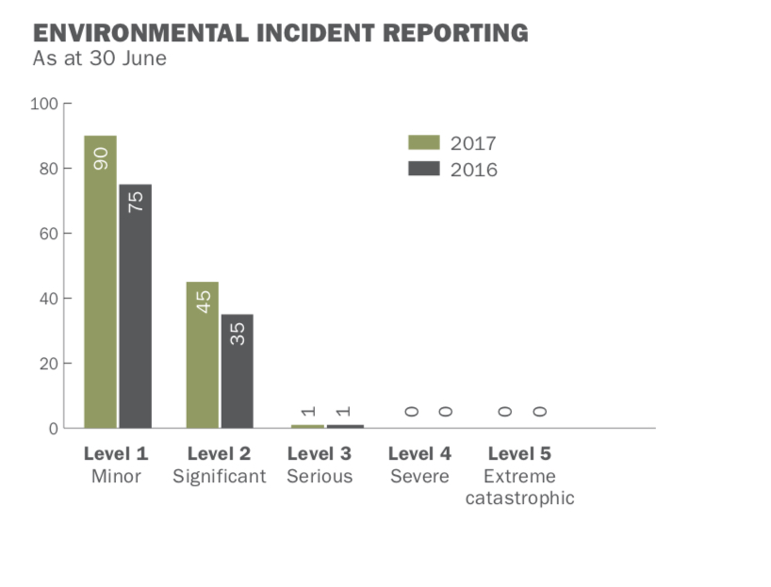

Fig: Environmental incident report

In year 2017, CSR incurred 136 environment incident as compared to 111 incident in the previous year following increase in level of production.

Level 3 incident occurred in 2017, when Dam 1 & 5 at the PHG Bringelly trick factory over spilled due to heavy rain and breached the discharge limit of turbidity.

Sustainability is a process where companies manage their triple botom line- fanincial, social and environmental risks, obligation and opportunities. These are the main three impact that sometimes reffered as planet, people and the profit. As we know that the business sustanability represents resiliency over time- business that can survive shocks because they are inimately connected to healthy economic, environmental and social system where business creates economic value and contribute to strong communkities and healthy ecosystems. CSR has very good relationship with the people and the commumnity. Usually they seek to engage withcommunities around all their sites to improve communication adress the main issue.

BHG bridge formed a new community consultative committee of key stakeholders of the brick site at bringely in year 2016, in NSW, Australia. This group are helping to resolve the matter raised by the community and minimise impact on that area.

One of the most important core component of their community involvement in the CSR Community support program which was formed in 2003 at that period CSR and their employee were donating $3 million to the charity and in year 2017, they donate $101635 to three main charatible organisation. They were: Assistance Dog Australia- it is a national charity which train Labradors & Golden Retirevers to help people with physical disability, Youth Of The Street- it is the specific charity which help young people or alienation from family & community and homeless, The Salvation Army- this one is the national charity which supports every problems “from the cradle to the grave”. They usually offer services to aged care facility, sucide prevention and the crisis accommodation. Because of which company makes place in the people heart and on the brain and thus company can earn or go for long period on the market.

# References

Anon., 2012. *Annual report,* australia: s.n.

Anon., 2018. *Annual report,* austraila: CSR ltd.